# **USER REQUIREMENTS**

# **Ration Balancing**

**PURPOSE:**

Thisprojectaims at developing a web application for calculating balanced ration for cattle. This web-based application will help the end user to keep a track of total amount of ingredients feed to the cattle per day along with the nutrition’s consumed. With this application the user can avoid the cumbersome calculations and get the required output with simple steps.

**TEAM MEMBERS:**

Hyndavi Musipatla

Lakshmi Seshu Kalvakuri

Sai Varun Reddy Anugu

Sanjana Tummala

Satyavrath Injamuri

Venkata Sai Karthik Reddy Bijjam

**MoSCoW Rules** Prepared By: Hyndavi Musipatla,

Lakshmi Seshu Kalvakuri

**Must have:**

* Must have the ingredients list and be able to select the ingredients.
* Must be able to select the cattle weight.
* Must be able to set the range(min-max) for nutrients and must be able to edit the nutrients.
* Must be able to take the quantity of ingredients from the user as input.
* Must be able to calculate the ration for the cattle considering weights.
* Calculation of how much each of all the ingredients make up to give between nutrition range.

**Should have:**

* Should have the ability to show the selected ingredients and can select all and deselect all the ingredients at a click.
* Should have a search bar for selecting an ingredient by name.
* Should have the ability to take the nutrient of user choice.

**Could have:**

* Could have the ability to set daily weight gain for the cattle growth.
* To display nutrient content for each ingredient.
* Could calculate ingredient quantity in lbs. based on %crude protein required for cattle.
* Could intake the dry matter as the percentage of the body weight.

**Would or won’t have:**

* Would have ability to select ingredients by the system based on cost and availability of stock.
* Would have the ability to store the history of ingredients feed to the cattle.
* Would have the ability to calculate the ration based upon the number of the cattle.

**UML DIAGRAM** Prepared By: Satyavrath Injamuri,

Venkata Sai Karthik Reddy Bijjam

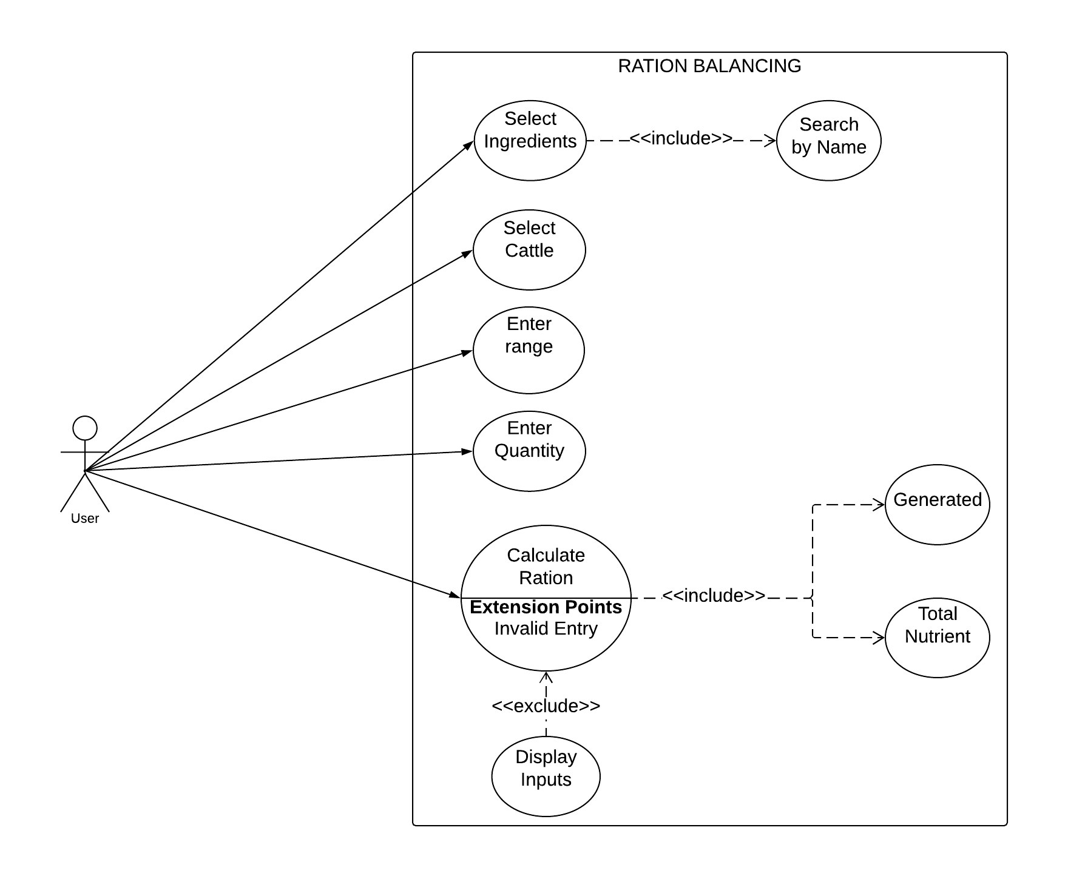

**PROTOTYPE** Prepared By: Sai Varun Reddy Anugu,

Sanjana Tummala

1. A screenshot of a cell phone

   Description automatically generatedHome Page

1. Select Ingredients from the list

3. Select cattle weight and Nutrition range.

4. Select ingredients quantity.

5. Final Output